Installation Guide of Fleet Service Application



Spartanburg Community College - 107 Community College Drive, Spartanburg, SC 29303- (864) 592-4600 - <https://www.sccsc.edu/>

Table of Contents

1. Introduction 2

2. Visual Studio Requirements 2

3. Downloading and First Start of the application 3

4. Setting up a new database to run the application on 5

5. Schema Script 7

6. SMTP Modification (Sender Email) 11

7. Publish the project and promoting on the server 12

Promoting to the server 15

8. Setting up an Event Viewer Log 17

# Introduction

Welcome to the installation guide for the Fleet Service program! This guide provides step-by-step instructions to help you install and set up the Fleet Service program on your system. The Fleet Service program is designed to streamline and manage the operations of a fleet management service, allowing you to efficiently track and maintain vehicles, manage inspections, and generate insightful reports.

# Visual Studio Requirements

To run the application in the visual studio you need to have the following Workloads installed in the visual studio.

* ASP.NET and web development

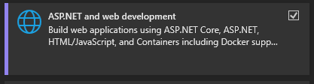

* Data storage and processing

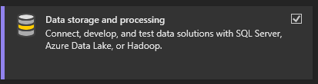

* Data science and analytical application



* .Net Framework 4.7.2 needs to be installed in visual studio to troubleshoot and publish the application through the Microsoft Visual Studio

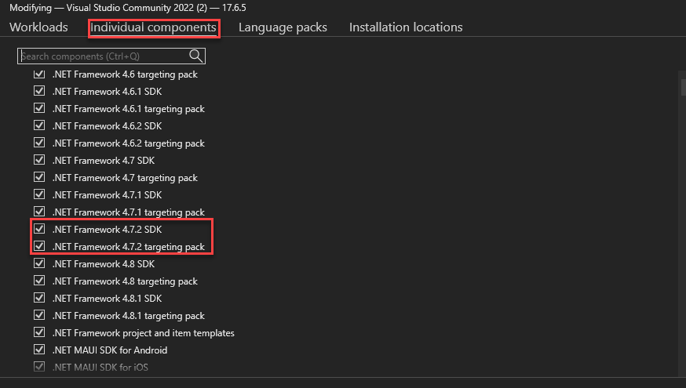

# Downloading and First Start of the application

Fleet Service application will be provided to the IT department by the SCC students from the Group 2 as a zip package of the application.

1. Once the application is provided to the IT as a zip folder, then the application needs to be unzipped

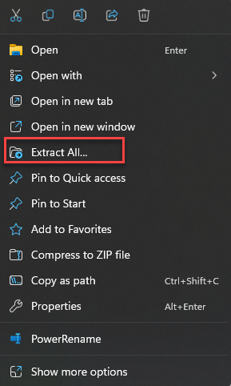

1. Once the application is unzipped, it can be started by clicking the “CPT-275 Capstone.sln”

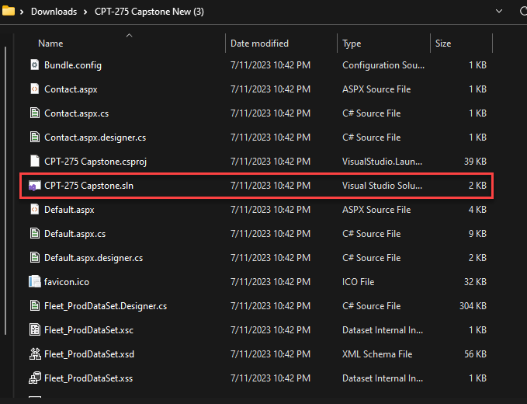

1. Once the application is opened in the Microsoft Visual Studio, the first thing that needs to be done in order to start the application is to point the application the new SQL server, with the new SQL database.

Fields that needs to be modified are: ConnectionString, Initial Catalog, User ID, Password

These are the credentials that are used to access the SQL server and the database that is on.

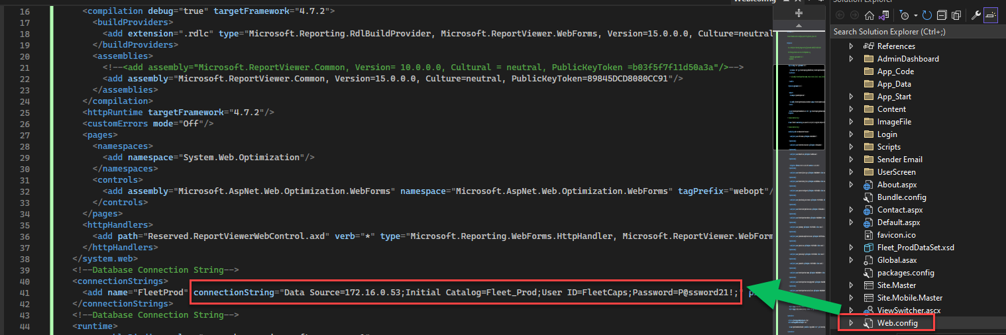

Second, set the Login page under the Login folder as a Start Page.

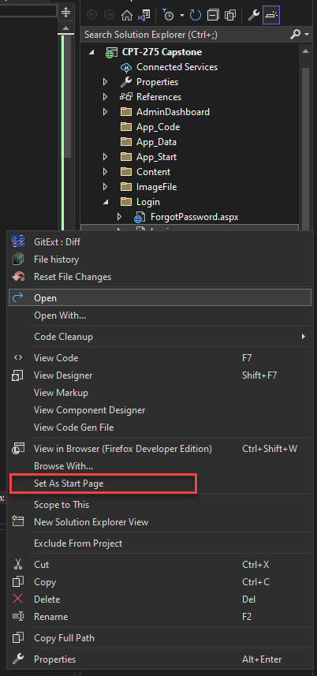

# Setting up a new database to run the application on

In order to run the application on the server the SQL database needs to be created with the correct table structure and reports to use to run the application.

To create a new database in the Microsoft SQL Server Management Studio, you would need to connect to the Database server and right click the “Databases” folder.

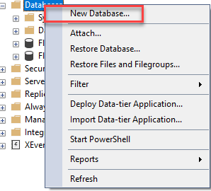

On the New Database prompt, you would need to enter a database name that will be used and give an access to the users that needs to have access to the database.

**Application does not require any accounts to have access to the database**

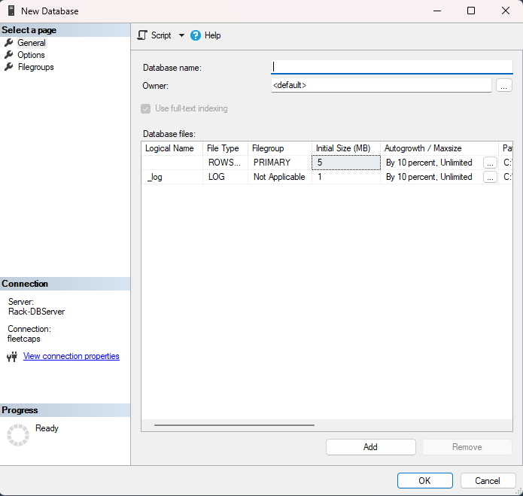

Once the database is created you would need to use the Schema script that was provided by the Lead Programmer of the application.

# Schema Script

--Create a vehicle table

CREATE TABLE vehicle (

    vehicle_id int identity (1,1) primary key,

    vehicle_year varchar(50) NOT NULL,

    vehicle_make varchar(255) not null,

    vehicle_model varchar (50) not null,

    vehicle_number char (20),

    vehicle_mileage char (50),

    vehicle_plate char (20),

    vehicle_no_default char (20),

);

--Users table

CREATE TABLE users(

    users_last_name varchar(50) NOT NULL,

    users_first_name varchar(50) NOT NULL,

    users_telephone char(10) NULL,

    users_email varchar(50) NULL,

    users_password char(20) NULL,

    users_DL char(20) NULL,

    users_DL_state [char](20) NULL,

    users_type char(20) NULL,

    vehicle_id int NULL,

    user_id int IDENTITY(1,1) NOT NULL,

PRIMARY KEY CLUSTERED

(

    [user_id] ASC

)WITH (PAD_INDEX = OFF, STATISTICS_NORECOMPUTE = OFF, IGNORE_DUP_KEY = OFF, ALLOW_ROW_LOCKS = ON, ALLOW_PAGE_LOCKS = ON, OPTIMIZE_FOR_SEQUENTIAL_KEY = OFF) ON [PRIMARY]

) ON [PRIMARY]

GO

--Inspection table

CREATE TABLE inspection(

    inspection_id int IDENTITY(1,1) NOT NULL,

    inspection_beginning_mileage decimal(18, 0) NOT NULL,

    inspection_ending_mileage decimal(18, 0) NOT NULL,

    inspection_total_mileage_driven decimal(18, 0) NULL,

    inspection_last_oil_change_date date NULL,

    inspection_oil_change_due date NULL,

    inspection_interval varchar(10) NULL,

    inspection_last_tire_rotation date NULL,

    inspection_tires_rotation_due date NULL,

    inspection_tires_pressure decimal(18, 0) NULL,

    vehicle_number int NULL,

    inspection_additional_notes varchar(250) NULL,

    trip_fluid_level varchar(10) NULL,

    battery_good varchar(10) NULL,

    gauge_working varchar(10) NULL,

    clean_cab varchar(10) NULL,

    clean_exterior varchar(10) NULL,

    inspection_date date NULL,

PRIMARY KEY CLUSTERED

(

    [inspection_id] ASC

)WITH (PAD_INDEX = OFF, STATISTICS_NORECOMPUTE = OFF, IGNORE_DUP_KEY = OFF, ALLOW_ROW_LOCKS = ON, ALLOW_PAGE_LOCKS = ON, OPTIMIZE_FOR_SEQUENTIAL_KEY = OFF) ON [PRIMARY]

) ON [PRIMARY]

GO

--Trip table

CREATE TABLE trip(

    trip_date date NULL,

    trip_beginning_mileage char(20) NOT NULL,

    trip_destination varchar(100) NOT NULL,

    trip_purpose varchar(100) NOT NULL,

    trip_ending_mileage varchar(20) NOT NULL,

    trip_total_miles char(20) NULL,

    vehicle_id varchar(150) NULL,

    user_id int NULL

);

--**Reports-----

--Inspection Report--------

/****** Object:  StoredProcedure [dbo].[inspection_report]    Script Date: 7/11/2023 9:58:03 PM ******/

/****** Object:  StoredProcedure [dbo].[inspection_report]    Script Date: 7/12/2023 10:57:53 PM ******/

SET ANSI_NULLS ON

GO

SET QUOTED_IDENTIFIER ON

GO

CREATE procedure inspection_report

(@beginning_date date, @ending_date date, @selected_vehicle int=null) as

if @selected_vehicle is null and @beginning_date is not null and @ending_date  is not null

begin

select

cast (v.vehicle_year+ ' '+v.vehicle_make+ ' ' +v.vehicle_model+ ' ' +v.vehicle_plate as varchar(50)) 'Vehicle',

i.inspection_beginning_mileage 'Beginning Mileage', i.inspection_ending_mileage 'Ending Mileage',

CONVERT(VARCHAR(10),i.inspection_last_oil_change_date,101) 'Last Oil Change', CONVERT(VARCHAR(10), i.inspection_oil_change_due,101) 'Oil Change Due',

CONVERT(VARCHAR(10),i.inspection_last_tire_rotation,101) 'Last Tire Change', CONVERT(VARCHAR(10),i.inspection_tires_rotation_due,101) 'Rotation Due',

i.inspection_tires_pressure 'Tire Pressure', i.inspection_additional_notes 'Additional Notes'

from inspection i join vehicle v on i.vehicle_number=v.vehicle_id

where inspection_date between @beginning_date and @ending_date

order by i.inspection_oil_change_due, inspection_date asc

end

else

begin

select

cast (v.vehicle_year+ ' '+v.vehicle_make+ ' ' +v.vehicle_model+ ' ' +v.vehicle_plate as varchar(50)) 'Vehicle',

i.inspection_beginning_mileage 'Beginning Mileage', i.inspection_ending_mileage 'Ending Mileage',

CONVERT(VARCHAR(10),i.inspection_last_oil_change_date,101) 'Last Oil Change',CONVERT(VARCHAR(10), i.inspection_oil_change_due,101) 'Oil Change Due',

CONVERT(VARCHAR(10),i.inspection_last_tire_rotation,101) 'Last Tire Change', CONVERT(VARCHAR(10),i.inspection_tires_rotation_due,101) 'Rotation Due',

i.inspection_tires_pressure 'Tire Pressure', i.inspection_additional_notes 'Additional Notes'

from inspection i join vehicle v on i.vehicle_number=v.vehicle_id

where inspection_date between @beginning_date and @ending_date

and @selected_vehicle=v.vehicle_id

order by i.inspection_oil_change_due, inspection_date asc

end

GO

--Trip Report

/****** Object:  StoredProcedure [dbo].[trip_report_new]    Script Date: 7/12/2023 10:58:37 PM ******/

SET ANSI_NULLS ON

GO

SET QUOTED_IDENTIFIER ON

GO

--Trip Date, Trip Destination, Trip Purpose, Trip Total Miles

--ALTER TABLE table_name

--RENAME COLUMN old_name TO new_name;

--ALTER TABLE employee ALTER COLUMN emp_parking_space BIGINT;

--EXEC sp_rename 'trip_report_new.trip_date', 'Trip Date';

CREATE procedure trip_report_new

(@trip_beginning_date DATETIME, @trip_ending_date DATETIME, @selectd_vehicle INT = null, @select_user INT = null) AS

if @select_user is null and @selectd_vehicle is null            -- SCENARIO 1: Date parameters included but No User and no Vehicle parameter

    begin

        print '1'

        select cast(u.users_last_name+', '+u.users_first_name as char(20)) 'Full Name', CONVERT(VARCHAR(10),t.trip_date,101) 'Trip Date', t.trip_destination 'Trip Destination',

        t.trip_purpose 'Trip Purpose', t.trip_total_miles 'Trip Total Miles', cast (v.vehicle_year+ ' '+v.vehicle_make+ ' ' +v.vehicle_model+ ' ' +v.vehicle_plate as varchar(50)) 'Vehicle'

        from trip t join vehicle v on t.vehicle_id=v.vehicle_id join users u on (t.user_id = u.user_id)

        where trip_date between @trip_beginning_date and  @trip_ending_date

        order by trip_date asc

    end

else if @select_user is null and @selectd_vehicle is NOT null   -- SCENARIO 2: Date and Vehicle parameters included but No User parameter

    begin

        print '2'

        select cast(u.users_last_name+', '+u.users_first_name as char(20)) 'Full Name',CONVERT(VARCHAR(10), t.trip_date,101) 'Trip Date', t.trip_destination 'Trip Destination',

        t.trip_purpose 'Trip Purpose', t.trip_total_miles'Trip Total Miles', cast (v.vehicle_year+ ' '+v.vehicle_make+ ' ' +v.vehicle_model+ ' ' +v.vehicle_plate as varchar(50)) 'Vehicle'

        from trip t join vehicle v on t.vehicle_id=v.vehicle_id join users u on (t.user_id = u.user_id)

        where trip_date between @trip_beginning_date and  @trip_ending_date and @selectd_vehicle = t.vehicle_id

        order by trip_date asc

    end

else if @select_user is not null and @selectd_vehicle is null   --  SCENARIO 3: Date and User parameters included but No Vehicle

    begin

        print '3'

        select cast(u.users_last_name+', '+u.users_first_name as char(20)) 'Full Name',CONVERT(VARCHAR(10), t.trip_date,101) 'Trip Date', t.trip_destination 'Trip Destination',

        t.trip_purpose 'Trip Purpose', t.trip_total_miles 'Trip Total Miles', cast (v.vehicle_year+ ' '+v.vehicle_make+ ' ' +v.vehicle_model+ ' ' +v.vehicle_plate as varchar(50)) 'Vehicle'

        from trip t join vehicle v on t.vehicle_id=v.vehicle_id join users u on (t.user_id = u.user_id)

        where trip_date between @trip_beginning_date and  @trip_ending_date and @select_user = u.user_id

        order by trip_date asc

    end

    else   -- SCENARIO 4: Both User and Vehicle parameters included with Date parameters

        begin

        print '4'

        select cast(u.users_last_name+', '+u.users_first_name as char(20)) 'Full Name',CONVERT(VARCHAR(10), t.trip_date,101) 'Trip Date', t.trip_destination 'Trip Destination',

        t.trip_purpose 'Trip Purpose', t.trip_total_miles 'Trip Total Miles', cast (v.vehicle_year+ ' '+v.vehicle_make+ ' ' +v.vehicle_model+ ' ' +v.vehicle_plate as varchar(50)) 'Vehicle'

        from trip t join vehicle v on t.vehicle_id=v.vehicle_id join users u on (t.user_id = u.user_id)

        where @select_user = u.user_id and @selectd_vehicle = t.vehicle_id and trip_date between @trip_beginning_date and  @trip_ending_date

        order by trip_date asc

end

GO

# SMTP Modification (Sender Email)

To modify the sender email from the application, you would need to find the SendEmail statements through the application, which are located in the following screens of the application:

* AdminDashboard Folder:
  + AddUser.aspx.cs
* Login Folder
  + ForgotPassword.aspx.cs
  + Register.aspx.cs

You will see the following statements in which you will need to enter the senderEmail, Senderpassword(password of the SMTP email to allow send out an emails), SmtpHost, and SMTP Port.

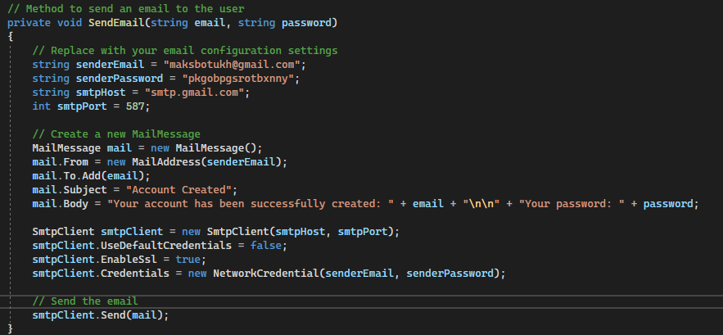

# Publish the project and promoting on the server

To publish the project from the visual studio you would need to right click the “CPT-275 Capstone” project in the Microsoft Visual Studio and click on Publish.

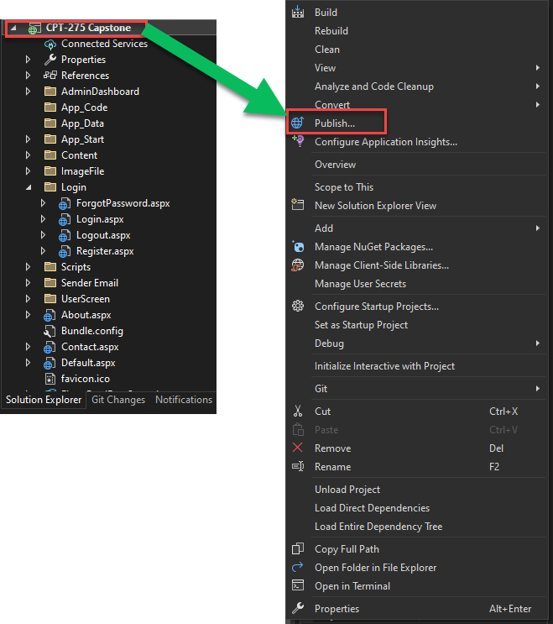

Once you clicked on the Publish button, you will select to publish to the Folder and point the location of where the folder will be located on your computer.

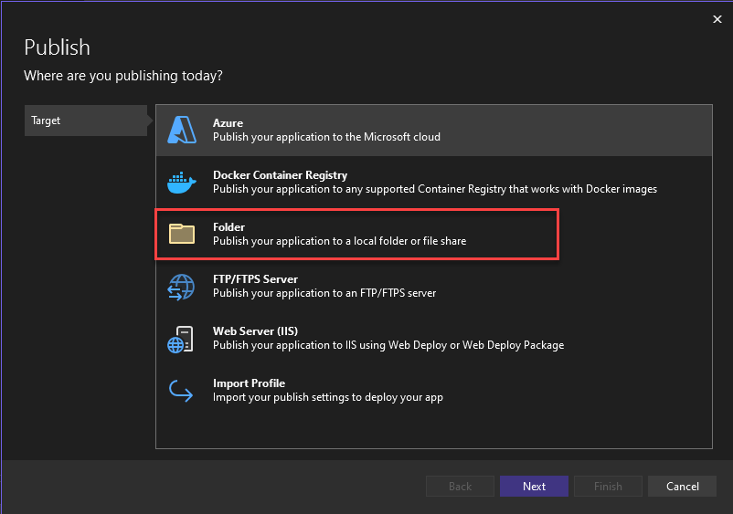

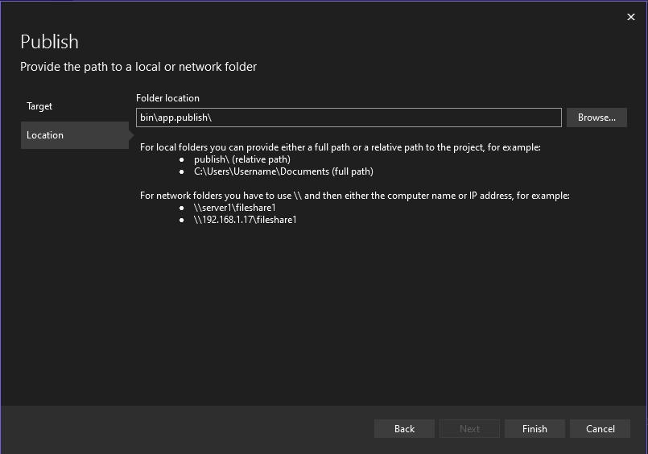

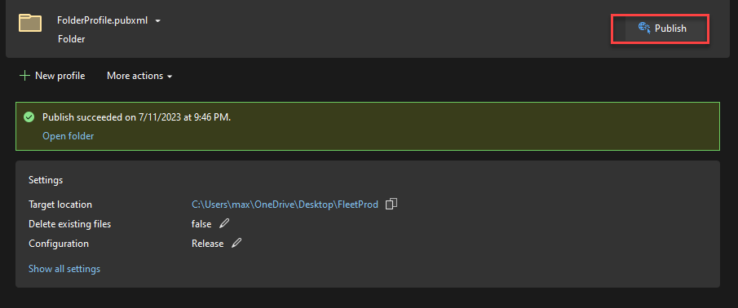

Once the publication is completed, the application can be found in the destination folder.

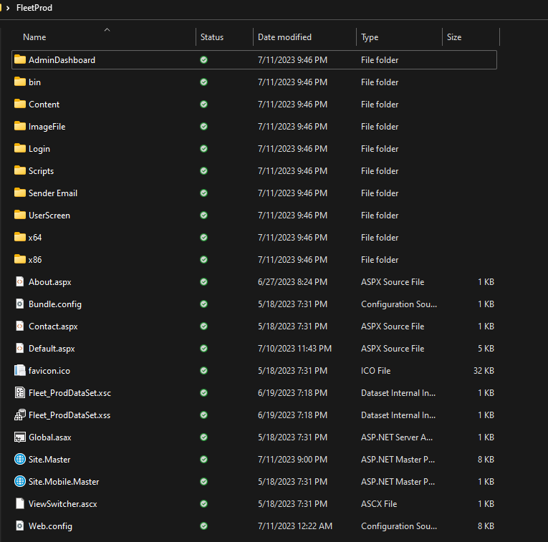

### Promoting to the server

When the application is published on the local computer it needs to be copied to the IIS on the server and applied to the Default Web Site, which should be associated to the AppPool of the application to run. The application can use the application identity and v 4.0 of .Net

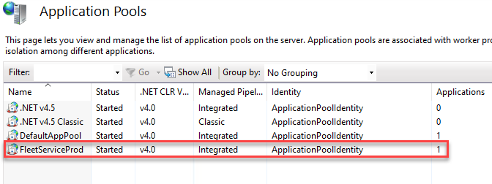

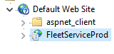

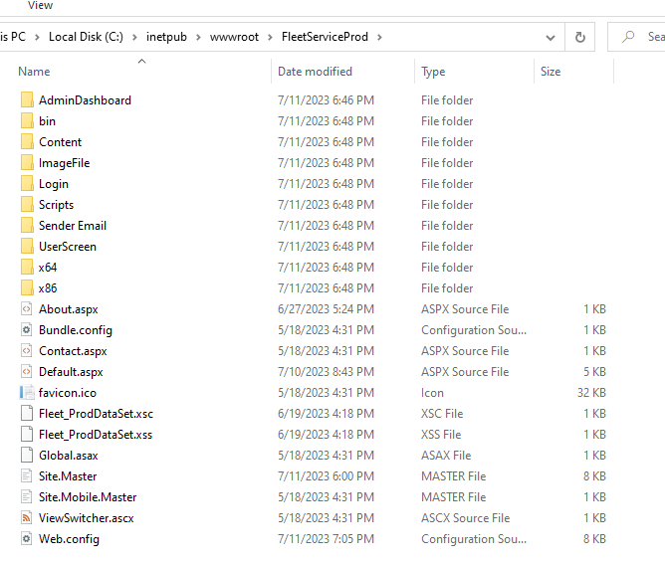

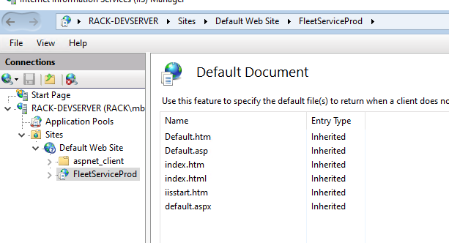

# Setting up an Event Viewer Log

The application uses the event viewer log to store all the errors and for easy troubleshooting if any issues occur.

Execute the following script in the PowerShell on the server where the application is hosted.

New-EventLog -source SCCFleetServices -LogName SCCFleetServiceEventLog

*For any questions associated with this Installation guide,*

*please contact us at via maksbotukh@gmail.com*